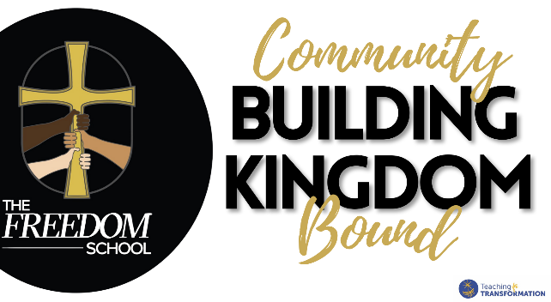
Job Description:
Part time Art Teacher

At The Freedom School, students are empowered and encouraged to be active and engaged learners. Our teachers provide an education that is both challenging and supportive. They work to ensure that students become active and curious learners – and are both local and global citizens fully prepared for the work our Lord calls them to. The Freedom School’s faculty embodies the values of academic excellence, authentic Christian community, and strong character building. Our focus is on RECONCILIATION: Reconciliation to God, self, and others. Our teachers are themselves learners, constantly searching for ways to improve their practice.
POSITION OVERVIEW: Responsible for providing lessons in art for students in PreK through 6th grade. Classrooms rotate through art over the course of 1.5 days this year.
PAY $22 per hour or commensurate with experience.

RESPONSIBILITIES
1. Establish and enforce rules for behavior and procedures for maintaining order in the classroom
2. Observe and evaluate students' performance, behavior, social development, and physical health.
3. Prepare materials and the classroom for class activities.
4. Adapt teaching methods and instructional materials to meet students' grade-level needs and interests.
5. Plan and conduct activities for a balanced program of instruction, demonstration, and work time that provides students with opportunities to observe, question, and investigate.
6. Instruct students individually and in groups, using various teaching methods such as lectures, discussions, and demonstrations.
7. Establish clear objectives for all lessons, units, and projects, and communicate those objectives.
8. Assign and grade class work and homework.
10. Maintain accurate and complete student records as required by law, district policies, and administrative regulations.
12. Work in conjunction with the Student Services Director to guide and counsel students with adjustment and/or academic problems.
13. Enforce administration policies and rules governing students.
14. Confer with other staff members to plan and schedule integrated lessons.
16. Use computers, audiovisual aids, and other equipment and materials to supplement presentations.
17. Prepare for assigned classes, and show written evidence of preparation upon request of immediate supervisors.
18. Instruct and monitor students in the use and care of equipment and materials, in order to prevent injuries and damage.
19. Organize and lead activities designed to promote physical, mental, and social development.
20. Attend professional meetings, educational conferences, and teacher training workshops in order to maintain and improve professional competence.
21. Attend staff meetings and serve on committees as required.
22. Assist in schoolwide standardized ability and achievement tests annually.
23. Differentiate instruction for those requiring assistive devices, accommodations, and assistance as needed.
KNOWLEDGE, SKILLS, AND ABILITIES
Candidates should be passionate about teaching and have a love for the Word of God
• Bachelor's degree, a teaching certificate or credential or equivalent professional experience
• Strong interpersonal and collaboration skills with the ability to communicate effectively and respectfully with all constituents.
• Excellent verbal and written communication skills are required.
• Strong Problem-solving skills
• Invests in the life of the school by participating in weekly department meetings and multidisciplinary team meetings, anti-bias training, and any and all aspects that support the student experience as available
• Demonstrated professional behavior, including discretion, judgment, and integrity.
• Effectively interacts with a diverse population of students and faculty.
• All prospective employees must be able to clear a background check, fingerprinting, and TB screening.
The Freedom School does not discriminate on the basis of race, color, denominational preference, or national origin in the administration of its educational or admission policies, financial aid distribution, or other school programs. We are dedicated to the goal of building a culturally diverse faculty committed to teaching and working in a multicultural environment.

